Hefei Jinhan Electronics Co., Ltd.--------http://www.jinhandz.cn
--------http://www.jinhandz.com


JDS100A、JDS100B、JDS100C Manual V1.0

Contents

1 Parameters - 2 -
1.1 Oscilloscope parameters - 2 -
1.2 Signal output parameters - 3 -
1.3 Parameter of professional multimeter - 4 -
1.4 Solenoid valve drive box parameters - 4 -
2 Oscilloscope Guide - 4 -
2.1 Control button - 4 -
2.2 Main interface - 5 -
2.3 Channel control menu - 6 -
2.4 Trigger control menu - 7 -
2.5 Time base control menu - 7 -
2.6 Function menu - 8 -
2.7 Oscilloscope control instructions - 10 -
3 Signal simulation - 11 -
4 Multimeter - 13 -
5 Auxiliary function description - 13 -
5.1 Set parameter - 13 -
5.2 One click screenshot - 14 -
5.3 One-button save waveform - 14 -
5.4One button saves the contrast waveform - 15 -
6 Key points of equipment operation - 15 -
6.1 Main points of oscilloscope - 15 -
6.2 Signal Generator - 15 -
6.3 Main Points of professional multimeter - 16 -
7 Software upgrade - 16 -
7.1 Built-in flash drive - 16 -
7.2Firmware upgrade - 16 -
8 JDS100A,JDS100B Some features require the user to purchase additional accessories to implement - 16 -
9 JDS100B Instructions for Solenoid Valve Drive Box - 17 -

●JDS100A and JDS100B are different for vehicle model parameter and configuration. See the parameter comparison table.
●The JDSS 100 C is a general purpose model.

1 Parameters

1.1 Oscilloscope parameters
Model | JDS100A  （Car repair type） | JDS100B  （Car repair type） | JDS100C  （Common type）
Language | Chinese, English, Russian, Spanish, Portuguese | Chinese, English, Russian, Spanish, Portuguese | Chinese, English, Russian, Spanish, Portuguese
Channel number | 1 | 1 | 1
Maximum real-time sampling rate | 5MSa/s | 5MSa/s | 5MSa/s
Bandwidth | 1M | 1M | 1M
Vertical resolution | 12 bit | 12 bit | 12 bit
Vertical gear | 200mV - 50V  1,2,5 step | 200mV - 50V  1,2,5 step | 200mV - 100V  1,2,5 step
Impedance | 1MΩ 25pF | 1MΩ 25pF | 1MΩ 25pF
Input Voltage | Less than 600V  Use high-voltage probes, the maximum voltage is determined by the quality of the probe | Less than 600V  Use high-voltage probes, the maximum voltage is determined by the quality of the probe | Less than 600V  Use high-voltage probes, the maximum voltage is determined by the quality of the probe
Time Base Range | 250ns - 5s  100ms - 5s (scan mode) | 250ns - 5s  100ms - 5s (scan mode) | 250ns - 5s  100ms - 5s (scan mode)
Storage depth | 3K | 3K | 3K
Trigger mode | Automatic, normal | Automatic, normal | Automatic, normal
Automatic detection | 50Hz - 1MHz | 50Hz - 1MHz | 50Hz - 1MHz
Cursor measurement | Time, voltage, current, pressure(Manual mode) | Time, voltage, current, pressure(Manual mode) | Time, voltage, current, pressure(Manual mode)
Recordable contrast waveform | 2 | 2 | 2
Screenshot function | Support | Support | Support
Self-calibration | Support | Support | Support
Screenshots number | 7 | 7 | 7
Number of saved waveforms | 30 | 30 | 30

1.2 Signal output parameters

Model | JDS100A  （Car repair type） | JDS100B  （Car repair type） | JDS100C  （Common type）
Channel number | 1 | 1 | 1
Frequency | 0.1Hz - 10KHz  Minimum Resolution 1/1000 | 0.1Hz - 10KHz  Minimum Resolution 1/1000 | 0.1Hz - 10KHz  Minimum Resolution 1/1000
Amplitude | 0V - 5V  Minimum Resolution 1/100 | 0V - 5V  Minimum Resolution 1/100 | 0V - 5V  Minimum Resolution 1/100
Duty cycle | 0% - 100%  Minimum Resolution 1/100 | 0% - 100%  Minimum Resolution 1/100 | 0% - 100%  Minimum Resolution 1/100
X,Y | 0-99 | 0-99 | None
Offsets | None | None | Maximum forward drift of 5v  Minimum Resolution 1/100  Negative offset Max 3vMinimum Resolution 1/100
Type of output waveform | DC waveform,Sine wave,Duty cycle waveform,xy Edentulous wave | DC waveform,Sine wave,Duty cycle waveform,xy Edentulous wave | DC waveform,Sine wave,Duty cycle waveform

1.3 Parameter of professional multimeter
Model | JDS100A  （Car repair type） | JDS100B  （Car repair type） | JDS100C  （Common type）
DC voltage | 0V - 600V | 0V - 600V | 0V - 600V
AC voltage | 0V - 400V(Valid values) | 0V - 400V(Valid values) | 0V - 400V(Valid values)
Resistance | 0Ω - 40MΩ | 0Ω - 40MΩ | 0Ω - 40MΩ
Capacitance | Max 100uf(30 seconds charging time) | Max 100uf(30 seconds charging time) | Max 100uf(30 seconds charging time)
Diode | 0V - 1.5V | 0V - 1.5V | 0V - 1.5V
On-off detection | Sound below 30Ω | Sound below 30Ω | Sound below 30Ω

1.4 Solenoid valve drive box parameters
Input Voltage | DC 12V
Number of input channels | 2
Number of output channels | 2
Maximum load current | 2.1A (2 channel overlay)
Duration under maximum load | 10 minutes
Protection Circuit | Support(After overload protection, you need to shut down and wait for 10 minutes before you can use it again)

2 Oscilloscope Guide

2.1 Control button
●JDS100A,JDS100B,JDS100C This operation is consistent.

button 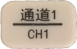 Oscilloscope one-button direct
button 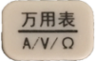 Multimeter one-click access
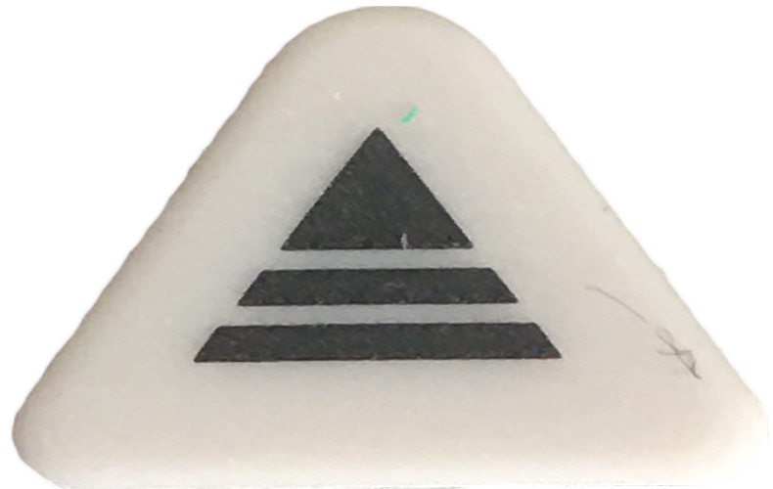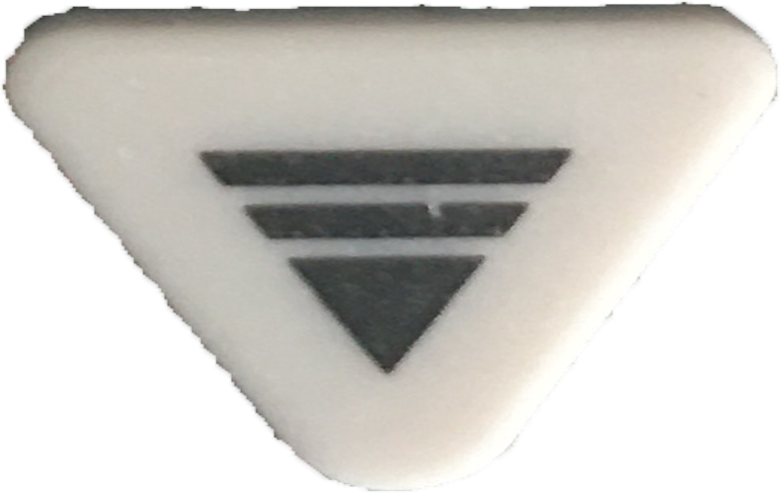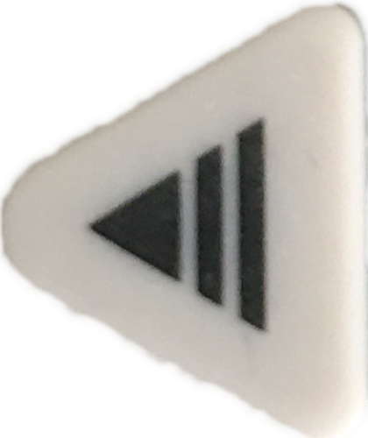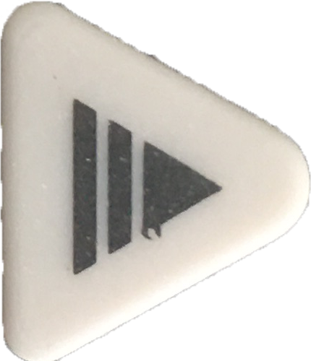Control key function selection

2.2 Main interface
Under the main interfaceControl key,Selection function,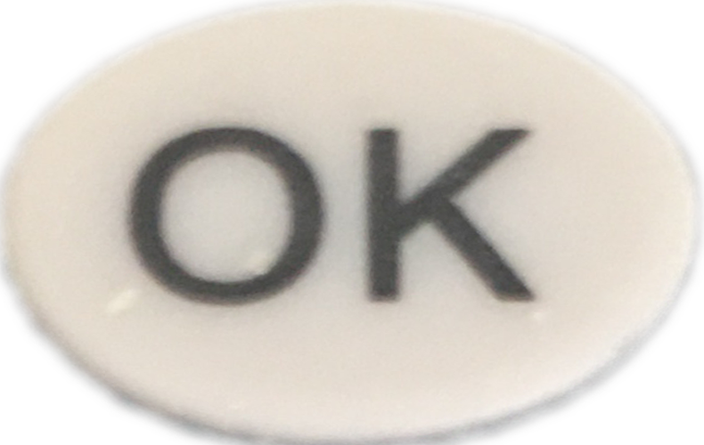Key confirmation to enter.
●JDS100A and JDS100BWith on-board signal prompt menu as follows:
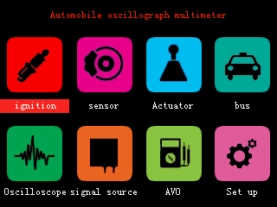
●JDS100C The main menu is as follows:
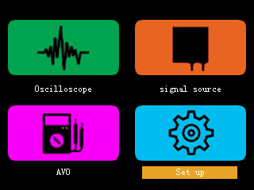

2.3 Channel control menu
●JDS100A,JDS100B,JDS100C This operation is consistent.
Press itEnter the CH1 channel control menu.
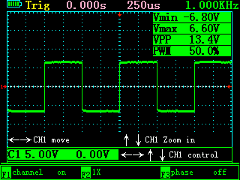

Under this interface
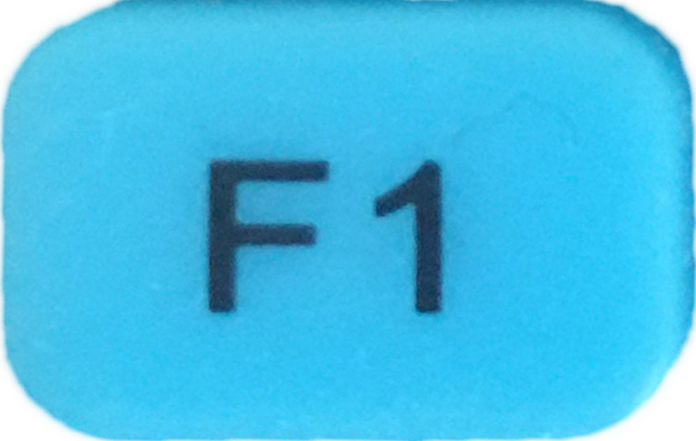Select whether to display the waveform of CH1
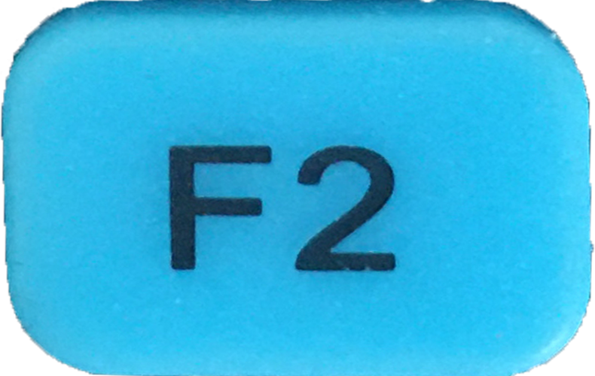he ratio of voltage to current and pressure can be selected according to the specific value
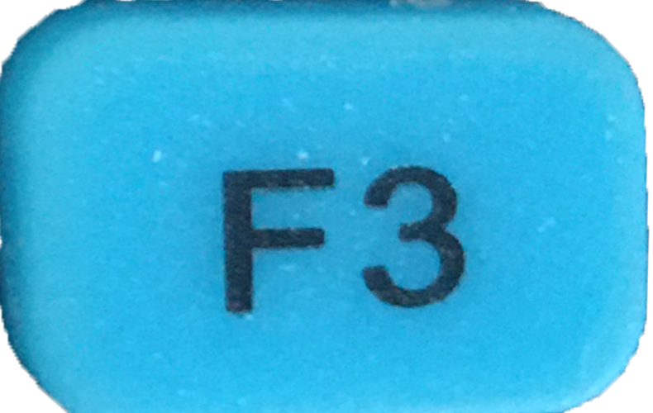elect whether to enable waveform inversion
In the case of a current clamp or pressure sensor,Hit It againhe key can select the corresponding unit
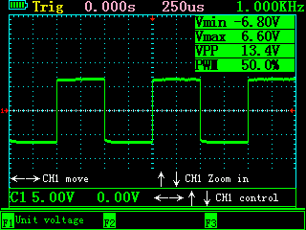

Change unit-voltage v-current A-pressure B
Null and void
Null and void

2.4 Trigger control menu
●JDS100A,JDS100B,JDS100C This operation is consistent.
Press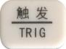Enter the trigger control menu.
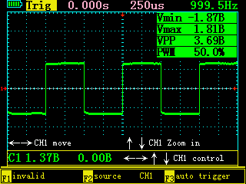
Invalid
Invalid
Select the trigger mode-auto trigger or normal trigger
Pay attention:
Auto trigger: When there is no trigger signal, the waveform data is displayed normally.
Normal trigger: The waveform data is displayed only when a trigger signal occurs.

2.5 Time base control menu
●JDS100A,JDS100B,JDS100C This operation is consistent.
Press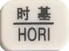Enter the time base control menu.

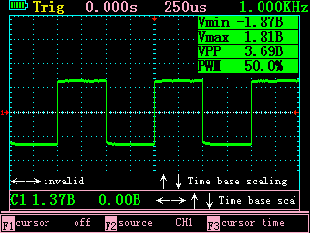
Whether the cursor is open or not
Invalid
Select the object of the measurement cursor, time or voltage.

2.6 Function menu
●JDS100A,JDS100B,JDS100C This operation is consistent.
Press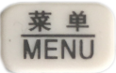Enter the contrast waveform control menu.
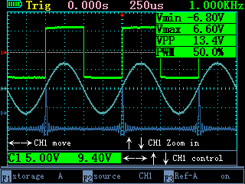

Choose to store contrast waveform A or B
Invalid
Select whether to display the contrast waveform.

Pay attention:
After opening the contrast waveform,The function of the key is to save the contrast waveform.
After the contrast waveform is turned off,Key function is to save the current waveform data to a file.
Hit It againEntry/exit mode set
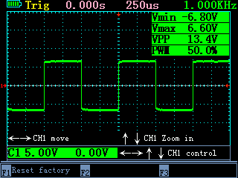

In-and-out mode
Invalid
Invalid
Invalid
Automatic calibration of waveform reference parameters
Return to factory settings
Pay attention:
Make sure there are no external connections before enabling automatic calibration!

2.7 Oscilloscope control instructions
●JDS100A,JDS100B,JDS100C This operation is consistent.

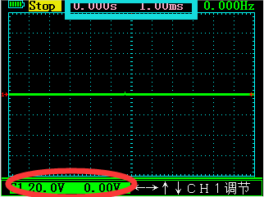
When the icon in the red box blinks
Control CH1 waveform movement
Control CH1 waveform shift

When the icon in the blue box blinks
Control vertical time base change

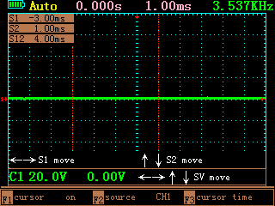
When the cursor is open and in the cursor menu
Control S1 movement
Control S2’s movement

3 Signal simulation
●JDS100A,JDS100B for vehicle signal simulator, with X + y crankshaft and camshaft signal simulation function.
●JDS100C does not have x + y crankshaft and camshaft signal simulation function.
●JDS100A, JDS100B signal simulation menu is as follows:
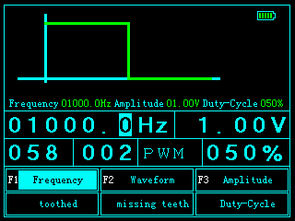
Choose Frequency ↔ X-Dentate
Choose Wave form ↔ Y-Missing Tooth
Choose Amplitude ↔ Duty cycle

Select number
Change the numbers

●JDS100C signal simulation menu is as follows:

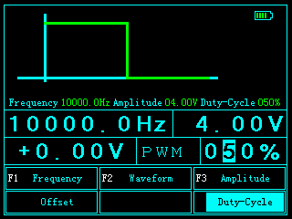
Choose Frequency ↔ Offset
Choose Wave form
Choose Amplitude ↔ Duty cycle
Select number
Change the numbers

Pay attention:Waveform output parameters are changed with the fact that the number changes.

4 Multimeter
●JDS100A,JDS100B,JDS100C This operation is consistent.
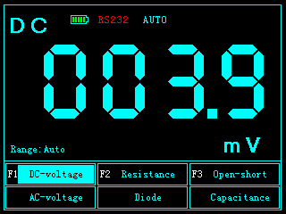
Choose DC voltage ↔ AC voltage
Choose Resistance ↔ Diode
Choose On and off ↔ Capacitance

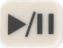 Static current display.

5 Auxiliary function description

5.1 Set parameter
●JDS100A,JDS100B,JDS100C This operation is consistent.
From the main menu into the settings, you can modify or view the relevant data.
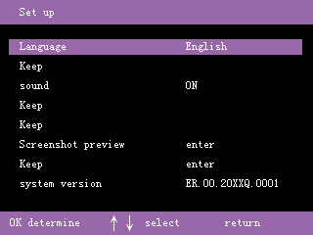
Language support for Chinese, English, Russian, Portuguese, Spanish.
The sound can be turned off.
The captured images and saved waveforms can be previewed and brought up for display.
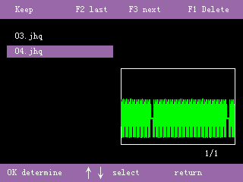

5.2 One click screenshot
●JDS100A,JDS100B,JDS100C This operation is consistent.
Long Press 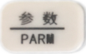key Will pop-up screenshot menu, select the screenshot save the number can be.(Number Range 0-7)

5.3 One-button save waveform
●JDS100A,JDS100B,JDS100C This operation is consistent.
With Ref_A and Ref_B both closed,Long Presswill eject waveform save vegetables,Just select the number of the waveform you want to save,(Number Range 0 - 29)

5.4One button saves the contrast waveform
●JDS100A,JDS100B,JDS100C This operation is consistent.
With Ref_A and Ref_B open closed,Long Pressto save contrast waveform.

6 Key points of equipment operation

6.1 Main points of oscilloscope

The trigger function of the local oscilloscope is automatically identified by the system, without user adjustment, users can choose to automatically trigger according to the actual display(Trigger or non-trigger waveform will be displayed, usually used for a strong signal periodic line).
Normal trigger(Display only the trigger signal, usually used to display the occasional signal, or a long interval of periodic signals).
JDS100A, JDS100B when a user uses an oscilloscope to measure a car signal,Do not recommend the use of one-click automatic functions, should be from the preset menu into the corresponding functions,Because of the difference between different models, when the presetting menu can not display the waveform completely, the time base or voltage gear can be adjusted manually to display the waveform.
For some waveform trigger is an occasional signal (waveform display sometimes and sometimes) , it is recommended to use the function of normal trigger, which can make waveform display more stable.
The waveforms or screenshots saved by the instrument, can be transferred to other instruments by means of a built-in U disk, so that important waveforms and data have commonality.

6.2 Signal Generator

DS100A,JDS100B Features (other than customizations) that users enter from the signal generator menu will have red area restrictions that indicate that they are not adjustable.
JDS100A, JDS100B signal generator signal, belongs to AC signal, there will be a negative voltage, but does not affect the overall range of 0v-5v.
JDS 100A, JDS 100B model according to the actual needs of the default adjustment offset value, DS100C model users can manually adjust the offset value according to their own needs.

6.3 Main Points of professional multimeter
●JDS100A,JDS100B,JDS100C This operation is consistent.
The maximum DC voltage should not exceed 600V.
The maximum AC voltage should not exceed 400V.
The larger the capacitance measurement, the longer the charging time, with a maximum of 100 UF requiring 30s.

7 Software upgrade

7.1 Built-in flash drive
●JDS100A,JDS100B,JDS100C This operation is consistent.
With the phone turned off,andPress at the same time will enter u-disk mode, at this time with USB cable connected to the computer, u-disk can be read content.

Account for:Screenshots of the machine, save the waveform file are in the U disk. Can be imported into the computer.

7.2Firmware upgrade
●JDS100A,JDS100B,JDS100C This operation is consistent.
When you enter U disk mode, you will upgrade the file updata. Bin copies the built-in USB drive (it’s best to format the built-in USB drive before copying it).Push the button to Upgrade.

8 JDS100A,JDS100B Some features require the user to purchase additional accessories to implement
Ignition->Secondary ignition
This function needs to use JH-01COP independent ignition probe to achieve
JH-01COP independent ignition probe is purchased by users
●JDS100AUsers need to buy banana head to BNC by themselves
●JDS100B Standard Banana Head to BNC.
Actuator->Engine cylinder pressure,Exhaust pressure,Intake pressure
This function needs to use JH-APT_100 pressure kit to achieve
JH-APT_100 pressure kit is purchased by users
●JDS100AUsers need to buy banana heads to turn BNC on their own
●JDS100B Standard Turn banana head to BNC.

A vehicle signal generator, for example, drives a high-current actuator.
●JDS100A Users need to buy the drive box by themselves.
●JDS100B Standard drive box.

9 JDS100B Instructions for Solenoid Valve Drive Box
Note:
It is best to adjust the output waveform before connecting the drive box, otherwise it may cause excessive current.
The maximum load current of this drive box is 2A, and the continuous working time of full load does not exceed 30 minutes.
The device has a protective device. If the circuit breaks due to overload, please turn off the device for 5 minutes and then reconnect it.
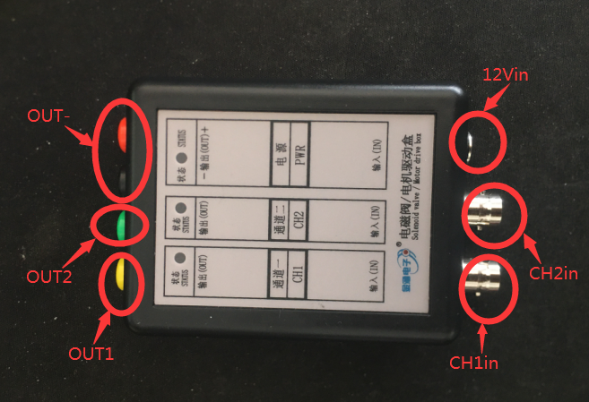

Connection method:
Turn the banana head to BNC connector and insert into the device,he GND plug into the Black Jack, and the Singnal plug into the signal export.
Pay attention to the positive and negative electrodes,
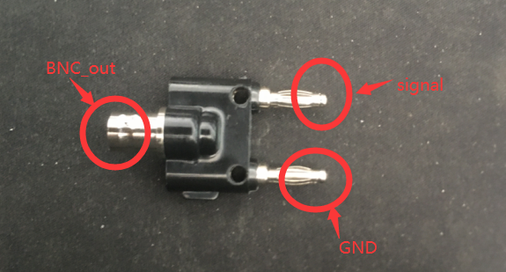

Use the BNC cable to connect the device to the drive box,BNC_out to connect the BNC_a,Connect to the CH1IN or CH2in of the drive box

Note: The Drive Box is dual-channel, but the instrument is single-channel output, so you can connect any channel.
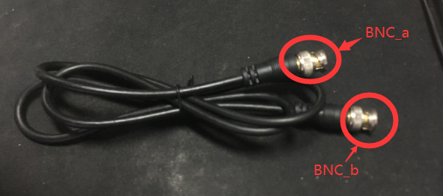
Then connect the power cord to a 12V voltage(A car battery or a power source).12V_Out connect 12vin of drive box

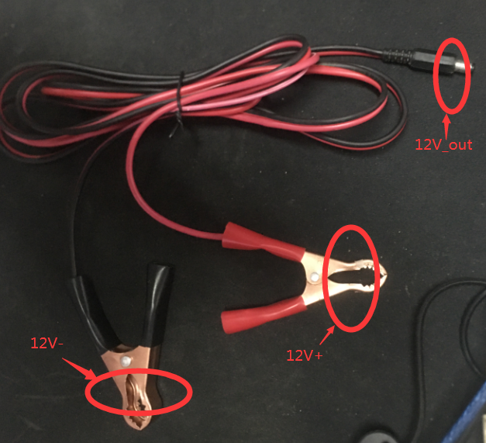
Set the waveform to output at the source, then link the device to be driven.Like an oil nozzle,

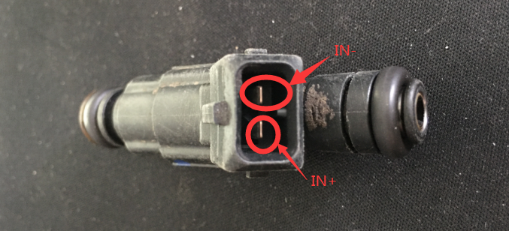
Link the OUT1 or Out2 of the drive box (Ch1in or CH2IN, depending on the input) to IN +,OUT- to conect IN-,
Adjust the frequency or duty cycle of the signal source to change the frequency or intensity of the injection.

